|  |  |  |  |  |  |
| --- | --- | --- | --- | --- | --- |
| **Semester II** | | | | | |
| **NO** | **Mata Kuliah** | **Kode** | **SKS** | **Jenis Perkuliahan** | **Keteterangan** |
| 1 | Kewarganegaraan | MBY08 | 2 | Full E-learning |  |
| 2 | Bahasa Indonesia | MBY09 | 2 | Full E-learning |  |
| 3 | Bahasa Inggris | MBY10 | 2 | Full E-learning |  |
| 4 | Biokimia Tanaman | AGR2135 | 2 | E-Learning |  |
| 5 | Praktikum Biokimia Tanaman | AGR2135P | 1 | Tatap Muka | Kelas A dan B |
| 6 | Fisiologi Tanaman | AGR2136 | 2 | Full E learning |  |
| 7 | Praktikum Fisiologi Tanaman | AGR2136P | 1 | Tatap muka | Kelas A dan B |
| 8 | Mikrobiologi Pertanian | AGR2137 | 2 | E-Learning |  |
| 9 | Praktikum Mikrobiologi Pertanian | AGR2137P | 1 | Tatap Muka | Kelas A dan B |
| 10 | Pengelolaan Air | AGR2138 | 2 | E-Learning |  |
| 11 | Praktikum Pengelolaan Air | AGR2138P | 1 | Tatap Muka | Kelas A dan B |
| 12 | Sosiologi Pertanian | AGR2139 | 2 | E-Learning |  |
| **Semester IV** | | | | | |
| **NO** | **Mata Kuliah** | **Kode** | **SKS** | **Jenis Perkuliahan** | **Keteterangan** |
| 1 | Kuliah Lapang Pertanian Terpadu | FAI2121P | 2 | Tatap Muka | Kelas A dan B |
| 2 | Kesuburan tanah | AGR2145 | 2 | Full E-learning |  |
| 3 | Praktikum Kesuburan tanah | AGR2145P | 1 | Tatap Muka | Kelas A dan B |
| 4 | Pemuliaan Tanaman | AGR2146 | 2 | E-Learning |  |
| 5 | Praktikum Pemuliaan Tanaman | AGR2146P | 1 | E-Learning |  |
| 6 | Agroklimatologi | AGR2147 | 2 | E-Learning |  |
| 7 | Praktikum Agroklimatologi | AGR2147P | 1 | Tatap Muka | Kelas A dan B |
| 8 | Ilmu Hama, Penyakit, dan Gulma | AGR2148 | 2 | E-Learning |  |
| 9 | Praktikum Ilmu Hama, Penyakit, dan Gulma | AGR2148P | 1 | Tatap Muka | Kelas A dan B |
| 10 | Konservasi Tanah dan Air | AGR2149 | 2 | Full E-learning |  |
| 11 | Meode Penelitian Surey | AGR2150 | 2 | E-Learning |  |
| 12 | *E-Business* | MNG2156 | 2 |  | Mengikuti kuliah di Prodi Managemen Kampus 1 |
| 13 | Praktikum *E-Business* | MNG2156P | 1 |  | Mengikuti Praktikum di Prodi Managemen Kampus 1 |
| **Semester VI** | | | | | |
| **NO** | **Mata Kuliah** | **Kode** | **SKS** | **Jenis Perkuliahan** | **Keteterangan** |
| 1 | Kuliah Kerja Nyata | MBY13P | 3 |  | Ditawarkan semester gasal dan Genap |
| 2 | Teknologi Benih | AGR2154 | 2 | Full E-learning |  |
| 3 | Praktikum Teknologi Benih | AGR2154P | 1 | Tatap Muka | Kelas A dan B dan kelas malam |
| 4 | Perbanyakan Vegetatif | AGR2155 | 2 | Full E-learning |  |
| 5 | Praktikum Perbanyakan Vegetatif | AGR2155P | 1 | Tatap Muka | Kelas A dan B |
| 6 | Pengelolaan Hama Terpadu | AGR2156 | 2 |  |  |
| 7 | Praktikum Pengelolaan Hama Terpadu | AGR2156P | 1 | Tatap muka | Kelas A dan B |
| 8 | Agroteknologi Tanaman Serealia dan Umbi | AGR2157 | 2 | E learning |  |
| 9 | Agroteknologi Tanaman Perkebunan | AGR2158 | 2 | E learning |  |
| 10 | Praktikum Agroteknologi Tanaman  Perkebunan | AGR2158P | 1 | Tatap muka | Kelas A dan B |
| 11 | Agribisnis | AGR2159P | 3 | E learning |  |
| **Semester VIII** | | | | | |
| **NO** | **Mata Kuliah** | **Kode** | **SKS** | **Jenis Perkuliahan** | **Keteterangan** |
| 1 | Praktek Kerja | AGR2160P | 3 | Tatap muka | Kelas 11C dan Kelas Malam Ditawarkan semester gasal dan Genap |
| 2 | Kolokium | AGR2168P | 1 | Full e Learning | Ditawarkan semester gasal dan genap |
| 3 | Skripsi | AGR2169P | 5 | Tatap muka | Kelas 11C dan Kelas Malam Ditawarkan semester gasal dan genap |
| dst |  |  |  |  |  |
|  |  |  |  |  |  |

**DAFTAR MATA KULIAH PROGRAM STUDI AGROTEKNOLOGI KAMPUS 1**

**SMESTER GENAP TA 2021/2022**

Catatan:

Elearning : perkuliahan dilaksanakan secara elearning (pengganti tatap muka)

Full elearning : matakuliah dlaksanakan secara full elearning

Tatap muka : perkuliahan dilaksanakan secara offline (tatap muka)

Yogyakarta, 27 Februari 2022

Ketua Program Studi Agroteknologi

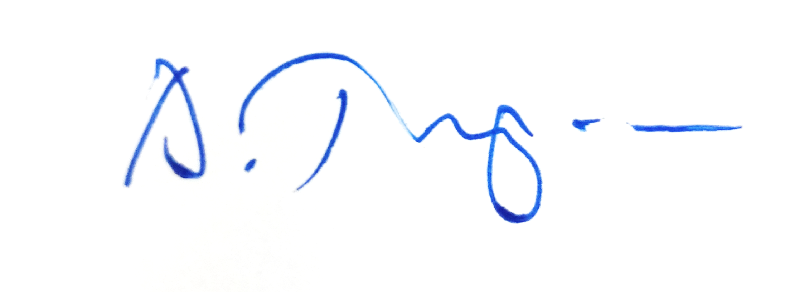

Dr. Ir. Bambang Nugroho, M.P.